Nolan Anderson
EE 384 Classwork 2 Due 14 September 2021

Problem 1
% a
x = [1 2 3 4 5 6 7 8];
X = fft(x)
% b
Y = ifft(X)
% c
N = length(x);
z = zeros(1, N);
Sum = 0;
for k = 1 : N
for L = 1 : N
Sum = Sum + x(L) * exp(-2*1i*pi*(L-1)*(k-1)/N);
end
z(k) = Sum;
Sum = 0;
end
for k = 1 : N
for L = 1 : N
Sum = Sum + z(L) * exp(2*1i*pi*(L-1)*(k-1)/N);
end
x(k) = (1/N) * Sum;
Sum = 0;
end
z
x

a) X = 36.0000 + 0.0000i -4.0000 + 9.6569i -4.0000 + 4.0000i -4.0000 + 1.6569i
-4.0000 + 0.0000i -4.0000 - 1.6569i -4.0000 - 4.0000i -4.0000 - 9.6569i
b) Y = 1 2 3 4 5 6 7 8
c)
i. z = 36.0000 + 0.0000i -4.0000 + 9.6569i -4.0000 + 4.0000i -4.0000 + 1.6569i -4.0000 - 0.0000i -4.0000 - 1.6569i -4.0000 - 4.0000i -4.0000 - 9.6569i
ii. x = 1.0000 - 0.0000i 2.0000 + 0.0000i 3.0000 - 0.0000i 4.0000 - 0.0000i
5.0000 - 0.0000i 6.0000 + 0.0000i 7.0000 + 0.0000i 8.0000 - 0.0000i

Problem 2
% a
f1 = 697; f2 = 1209; fs = 8000; % 697 Hz / 1209 Hz / 8 kHz
dt = 1/fs;
t = 0 : dt : 1-dt;
y = sin(2*pi*f1*t) + sin(2*pi*f2*t);
plot(t, y), xlabel('t'), ylabel('y(t)'), title('Problem 2a');
% b
figure
y_psd = periodogram(y);
plot(10*log10(y_psd))
title('Frequence spectrum using Matlab function periodogram')
xlabel('Frequency (Hz)'), ylabel('dB')
text(697, 10*log10(y_psd(697)), ' 697 Hz \rightarrow', 'HorizontalAlignment','right');
text(1209, 10*log10(y_psd(1209)), ' 697 Hz \rightarrow', 'HorizontalAlignment','right');
% c
% see screenshot below.
% d
L = length(y);
n = pow2(nextpow2(L));
y_dft = fft(y, n);
y_s = fftshift(y_dft);
f = (-n/2 : n/2 - 1) * (fs / n);
figure
plot(f, abs(y_s) / n);
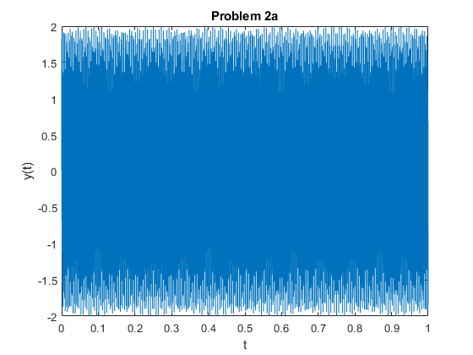
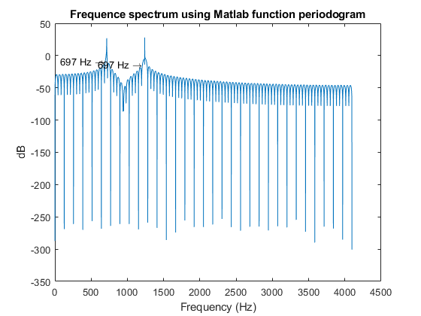
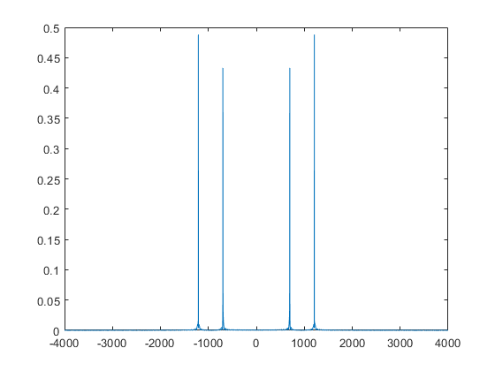

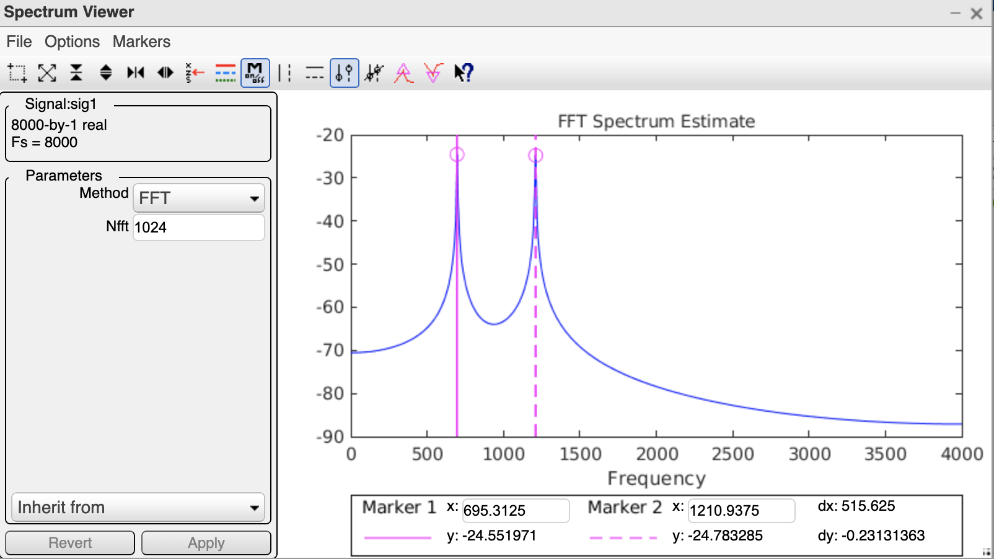Published with MATLAB® R2020b

